DATA MINING
ASSIGNMENT-1

5. Analyze Data 1 and Data 2 using linear regression

(a) Plot J(w) against iteration for Data 1 & Data 2.

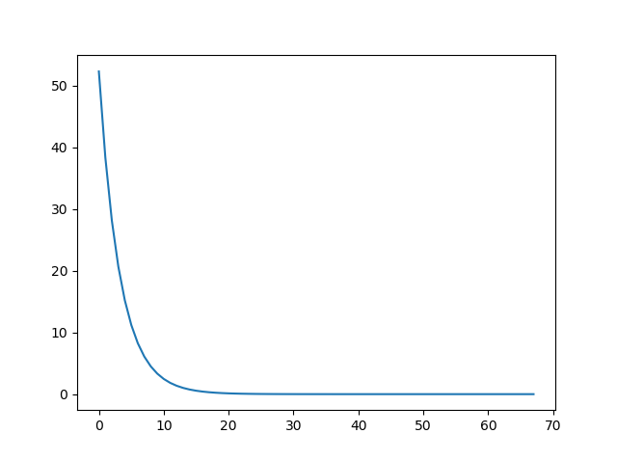

Figure 1: J(w) against iteration for Data 1

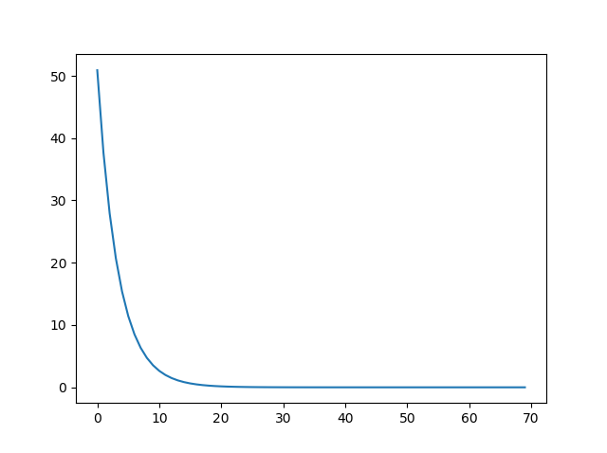

Figure 2: J(w) against iteration for Data 2

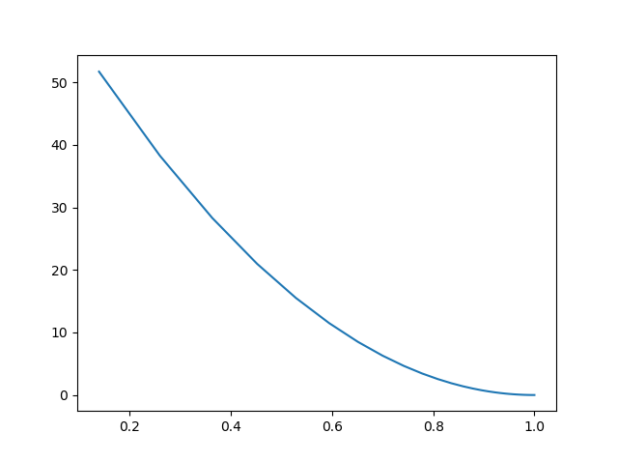
(b) Plot J(w) against w obtained in each iteration for Data 1.

Figure 3: J(w) against w obtained in each iteration for Data 1.
(c) Plot the hyperplane that generates the data.
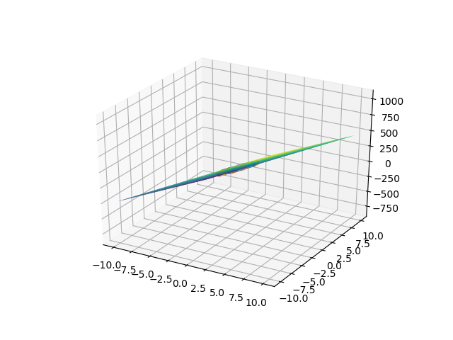

Figure 4: Hyperplane for Data 2

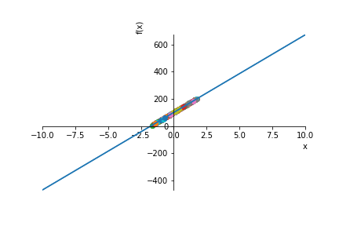

Figure 5: Hyperplane for Data 1

(d) Report the parameters of the model.
w for Data 1:
w values are stored in w_data1.csv
w for Data 2:
w values are stored in w_data2.csv

8. Analyze Data 3 using linear regression

a) Find the parameters using direct method and iterative methods.
Parameters using direct method:
w values are stored in w_data3_direct.csv

Parameters using iterative method:
w values are stored in w_data3_iterative.csv

(b) Compare the time taken and space requirements of two approaches.

Running time for direct method is .745678965408 seconds
Running time for iterative method (with cross validation) is 981.346298273 seconds

Space Complexity of Direct method for Data 3 is O (n+1*n+1)
Space Complexity of Iterative method for Data 3 is O (n+1)

(c) Report the values of the hyperparameters and parameters of the model.

Hyper parameter: alpha=0.001

d) Analyze the performance of the model.

Root mean square error of Direct Method is 7.994839604152386e-06
Root mean square error of Iterative Method is 0.13220189670138113

9. Analyze Data 4 using linear regression

(a) Report the values of the parameters of the model.

w values are stored in w _data 4.csv

(b) Analyze the performance of the model
Root mean square error is 0.543421452478558

10. Analyze Wine quality data set using linear regression.

(a) Specify the preprocessing methods applied on the data.

Header is removed using skiprows and z-score normalization is used to normalize the data.

(c) Assess the performance of the model.

Root mean square is 0.43859222805738749

(d) Report the values of the hyperparameters and the parameters of the model.

Hyperparameter alpha=1e-5
w values for batch are stored in w_data_wine_batch.csv
w values for batch are stored in w_data_wine_iterative.csv

e) Apply batch as well as online optimization algorithms and compare their performance.
Root mean square error of batch optimization is 0.983922280573874
Root mean square error of online optimization is 1.6528237844954068

submitted by
SRIKANT NAYAK
SC18M005

